**DAY_6_VPC**

DAY6_VPC_CE1

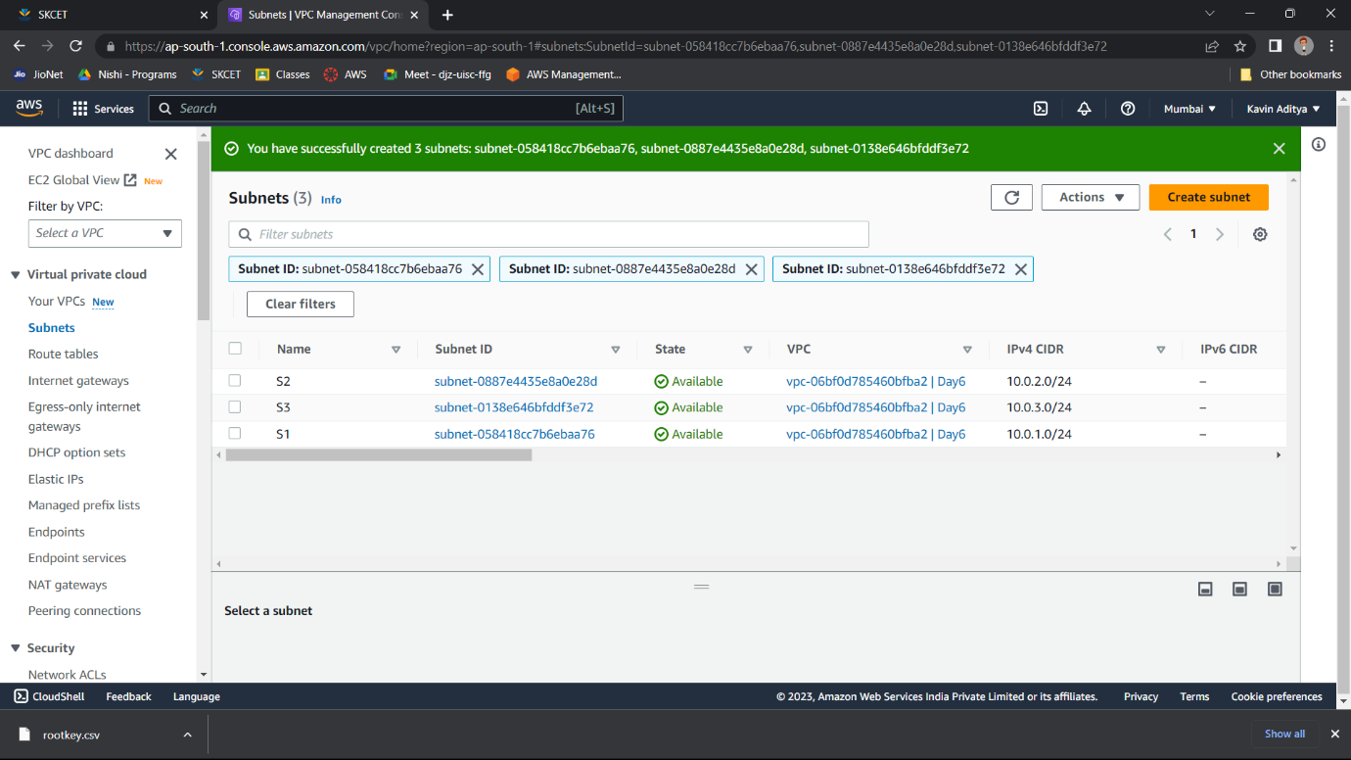

DAY6_VPC_CE2

DAY6_VPC_CE3

DAY6_VPC_CE4

DAY6_VPC_CE5

DAY6_VPC_CE6

